**Phase-1: Implementation**

|  |  |  |  |  |  |
| --- | --- | --- | --- | --- | --- |
| **Phases** | **Targeted Implementations** | **Tools Required** | **Number of instances** | **Status/duration** | **Supporting Documents** |
| **Phase-1.1** | Install the required tools to check out the code from GitHub and then build. | Java, Tomcat, Maven, Git, Jenkins | 1 RHEL | 2 hrs | 1.AWS-TOMCAT-JENKINS.doc, 2.Java-Tomcat-maven-git-Jenkins.sh |
| **Phase-1.2** | Implement as to get the code from GitHub--->build with maven-->deploy to nexus-->deploy to TomCat server. | Above tools + Nexus | 2 RHEL | 2 hrs | 3.NexusSetup.sh |
| **Phase-1.3** | Jenkins master and slaves configuration. | Above tools | 3 RHEL | Completed in one day | 4.AWS-Jenkins-Slaves-Configuration.doc |
| **Phase-1.4** | Documentation of Phase-1 tasks | Google Docs/sheets | - | Completed in one day | **DevOps-Setup-Phase1-FinalDocs.zip** |

Required Tools & servers:

|  |  |  |
| --- | --- | --- |
| Server1 | Server2 | Server3 |
| Java  Tomcat  Maven  Git  Jenkins | Nexus | Slave |

**Communication b/w servers**:

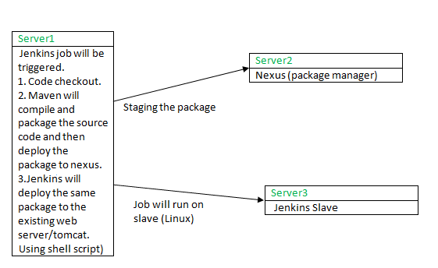

|  |  |  |  |  |  |
| --- | --- | --- | --- | --- | --- |
| **Phases** | **Targeted Implementations** | **Tools Required** | **Number of instances** | **Status/duration** | **Supporting Documents**  **(Follow the same sequence to refer docs)** |
| **Phase-2.1** | Deploy using Ansible with jenkins free style job as wells as pipeline script. | Java, Tomcat, Maven, Git, Jenkins,  Ansible | Total 3 RHELs. | Completed in four days | 2.1.1. AWS-ANSIBLE.txt  2.1.2. AWS-ANSIBLE.doc |
| Tools on 1st RHEL = Java, Tomcat, Maven, Git, Jenkins,  Ansible. |
| Tools on 2nd RHEL = java, tomcat. |
| 3rd RHEL = Jenkins slave |
| **Phase-2.2** | Docker (containerization) | Java, Tomcat, Maven, Git, Jenkins,  Docker | Total 3 RHELs. | Completed in three days | 2.2.1. AWS-Docker-Introduction.sh  2.2.2. Docker-Practice-1.txt  2.2.3. Docker-Practice-1.doc  2.2.4. Docker-Practice-2.sh  2.2.5. Docker-Practice-2.doc |
| Tools on 1st RHEL= Java, Tomcat, Maven, Git, Jenkins. |
| Tools on 2nd RHEL = java, tomcat. |
| 3rd RHEL = Jenkins slave, docker, git, java. |
| **Phase-2.3** | Documentation of Phase-2 tasks | Doc | - | Completed in one day | DevOps-Setup-Phase2-FinalDocs.zip |

**Docker workflow**:

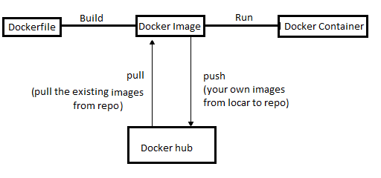

**Phase-3: Implementation**

|  |  |  |  |  |  |
| --- | --- | --- | --- | --- | --- |
| **Phases** | **Targeted Implementations** | **Tools Required** | **Number of instances** | **Status/duration** | **Supporting Documents** |
| **Phase-3.1** | JIRA Installation with DB | JIRA, PostgreSQL | 1 RHEL | 2 hrs | **Phase-3.1** |
| **Phase-3.2** | Practical JIRA with Jenkins+GitHub | Java, Tomcat, Maven, Git, Jenkins, JIRA | 2 RHEL | Completed in three days | **Phase-3.2** |
| **Phase-3.3** | SonarQuebe with DB | SONAR, PostgreSQL | 1 Ubuntu | 2 hrs | **Phase-3.3** |
| **Phase-3.4** | Practical SONAR with Jenkisn+GitHub(Jenkins + Maven + Sonar integration) | Java, Tomcat, Maven, Git, Jenkins, SONAR | 2 RHEL | Completed in four days | **Phase-3.4** |

**Phase-4: Implementation**

|  |  |  |  |  |  |
| --- | --- | --- | --- | --- | --- |
| **Phases** | **Targeted Implementations** | **Tools Required** | **Number of instances** | **Status/duration** | **Supporting Documents** |
| **Phase-4.1** | Bitbucket installation with DB | Bitbucket, PostgreSQL | 1 Ubuntu | Completed in one day | AWS-Bitbucket-PostgreSQL.sh, AWS-Bitbucket-PostgreSQL-Installation.doc |
| **Phase-4.2** | Integration of the tools: Bitbucket + JIRA | - | - | Completed in one day | AWS-Bitbucket-JIRA-PostgreSQL.doc |
| **Phase-4.3** | Integration of the tools &CI Setup: Bitbucket + JIRA, Bitbucket + Jenkins, JIRA + Jenkins | Jenkins,Git, Bitbucket, JIRA, Maven, tomcat | 1 Ubuntu, 2 RHEL | Completed in one day | AWS-Jenkins-Bitbucket-JIRA-CI-CD-Practice.doc |
| **Phase-4.4** | Documentation of Phase-5 tasks | Google Docs/sheets | - | Completed in one day | **DevOps-Setup-Phase4-Docs-v0.2.zip** |

Simple work-flow:

Requirement (in terms of JIRA task issue) 🡪Coding in local machine and then push to remote server like bitbucket🡪Automatic Jenkins job build on new changes🡪Deploy the package to tomcat server.🡪 if any issues open a bug/defect issue in JIRA to the dev team. Repeat the steps. i.e., CI --- Continuous Integration.

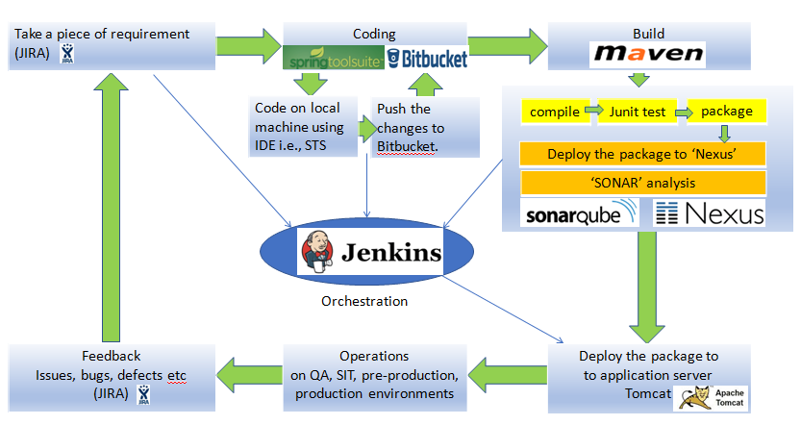

Required Tools & servers:

|  |  |  |  |
| --- | --- | --- | --- |
| **Server/Type** | Server1(RHEL) | Server2 (Ubuntu) | Server3(RHEL) |
| **Server Activity** | Jenkins master | Bitbucket - code repository | JIRA – bug tracker OR issue management OR project management tool |
| **Tools** need to be installed | Java, Tomcat, Maven, Git, Jenkins | Bitbucket  PostgreSQL | JIRA  PostgreSQL |

Communication between servers:

|  |
| --- |
| Server2(Ubuntu) |
| Bitbucket - code repository |
| Bitbucket with PostgreSQL.  Build bucket integrated with Jenkins. Once the code pushed to the repo, the Jenkins job will be triggered automatically. |

|  |
| --- |
| Server1(Linux) |
| Jenkins master |
| Checkout the code & Build the recently checked-in code. |
| Deploy the package to nexus server. (as per Phase-1 implementation) |
| Deploy the package to Tomcat server. |

Build the latest code

As per one of the project requirement, developer will work on one of the project **JIRA task** and changes will be pushed into the code repo (Bitbucket server) with the JIRA reference issue.

|  |
| --- |
| Server3(Linux) |
| JIRA – bug tracker |
| JIRA with PostgreSQL and this server integrated to Bitbucket server (server2) and Jenkins server (server1).  Epics, Stories, Tasks, Bugs, defects are managed in JIRA projects. |

After manual test or   
  
 automated selenium,  
  
 the test engineer will   
  
 open a defect or bug in  
  
 JIRA to fix the error   
  
 if any error  
  
 occurred while testing.

(See the below image, in case the above tables are not proper in your word document)

**Phase-5: Implementation**

|  |  |  |  |  |  |
| --- | --- | --- | --- | --- | --- |
| **Phases** | **Targeted Implementations** | **Tools Required** | **Number of instances** | **Status/duration** | **Supporting Documents** |
| **Phase-5.1** | Selenium Grid Installation | Java, Selenium JAR | Local Windows | Completed in one day | Jenkins+Maven+Selenium-OnLocalWindows.doc |
| **Phase-5.2** | Selenium + Maven + Jenkins with sample code web application automatic testing. | Java, Maven, Jenkins | Local Windows | Completed in one day | Refer the same above doc |
| **Phase-5.3** | AWS-Jenkins-Slaves-Linux-And-Windows-Configuration | Java | 2RHEL, 1 Windows - AWS | Completed in one day | AWS-Jenkins-Slaves-Linux-And-Windows-Configuration.doc |
| **Phase-5.4** | Selenium Grid Installation on AWS windows | Java, Selenium jar | 1 Windows | Completed in one day | Jenkins+Maven+Selenium-OnAWS.doc |
| **Phase-5.5** | Selenium + Maven + Jenkins on AWS Linux, Ubuntu, Windows instances | Java, Jenkins, Maven, Selenium Grid | 2RHEL,  1Windows | Completed in one day | Refer the same above doc |
| **Phase-5.6** | Documentation of Phase-5 tasks | Google Docs/sheets | - | Completed in one day | **DevOps-Setup-Phase5-Docs-v0.3.zip** |

Example work-flow:

Original Code check-in for web app 🡪 Prepare Selenium script to test the web pages in different browsers 🡪 Trigger a local maven build OR trigger a Jenkins job as to Build the original code 🡪 deploy the package to Tomcat server 🡪 build the Selenium job to run the automated test cases to check the web pages in different browsers.

Required Tools & servers:

|  |  |  |  |
| --- | --- | --- | --- |
| **Server/Type** | Server1(RHEL) | Server2 (RHEL) | Server3(Windows) |
| **Server Activity** | Jenkins master | Slave node to Jenkins master | Slave node to Jenkins master |
| **Tools** need to be installed | Java  Tomcat  Maven  Git  Jenkins | Java  Git  Maven  Tomcat | Java  Git  Maven  Selenium Grid  All required browsers |

Communication between servers:

|  |
| --- |
| Server2(Linux) |
| Slave node to Jenkins master |
| Always available |

|  |
| --- |
| Server1(Linux) |
| Jenkins master |
| Checkout the code & Build the original code. |
| Deploy the package to Tomcat server. |
| Run the Selenium job on Jenkins widows slave as to run the automated test cases to check the web pages in different browsers. |

Build the Original Code

|  |
| --- |
| Server3(Windows) |
| Slave node to Jenkins master |
| Only available to Selenium job. |

Run the Selenium script  
  
on windows

**Phase-6: Implementation**

|  |  |  |  |  |  |
| --- | --- | --- | --- | --- | --- |
| **Phases** | **Targeted Implementations** | **Tools Required** | **Number of instances** | **Status/duration** | **Supporting Documents** |
| **Phase-6.1** | LDAP with Jenkins | Java, Jenkins, LDAP | 1 RHEL, 1 Ubuntu | **Phase-6.1** | LDAP with Jenkins |
| **Phase-6.2** | LDAP with JIRA | JIRA, PostgreSQL, LDAP | 1 RHEL, 1 Ubuntu | **Phase-6.2** | LDAP with JIRA |
| **Phase-6.3** | LDAP with Bitbucket | Bitbucket, PostgreSQL, LDAP | 2 Ubuntu | **Phase-6.3** | LDAP with Bitbucket |
| **Phase-6.4** | LDAP with SonarQube | Sonar, PostgreSQL, LDAP | 1 RHEL, 1 Ubuntu | **Phase-6.4** | LDAP with SonarQube |
| **Phase-6.5** | LDAP with Splunk | Splunk, LDAP | 1 RHEL, 1 Ubuntu | **Phase-6.5** | LDAP with Splunk |
| **Phase-6.6** | LDAP with Nagios | Nagios, LDAP | 1 RHEL, 1 Ubuntu | **Phase-6.6** | LDAP with Nagios |
| **Phase-6.7** | LDAP with Nexus | Nexus, LDAP | 1 RHEL, 1 Ubuntu | **Phase-6.7** | LDAP with Nexus |

**Phase-7&8: Implementation**

|  |  |  |  |  |  |
| --- | --- | --- | --- | --- | --- |
| **Phases** | **Targeted Implementations** | **Tools Required** | **Number of instances** | **Status/duration** | **Supporting Documents** |
| **Phase-7.1** | Splunk |  | 1 RHEL, 1 Ubuntu | **Phase-7.1** | Splunk |
| **Phase-7.2** | Monitoring tools setup NAGIOS or any similar tools |  | 1 RHEL, 1 Ubuntu | **Phase-7.2** | Monitoring tools setup NAGIOS or any similar tools |
| **Phase-7.3** | Jenkins + Ansible integration |  | 1 RHEL, 1 Ubuntu | **Phase-7.3** | Jenkins + Ansible integration |
| **Phase-7.4** | Jenkins + Docker integration |  | 1 RHEL, 1 Ubuntu | **Phase-7.4** | Jenkins + Docker integration |
| **Phase-7.5** | Documentation of Phase-6 tasks | Docs/sheets |  | **Phase-7.5** | Documentation of Phase-6 tasks |
| **Phase-8.1** | Automatic provisioning AWS CLI or TERRAFORM or ANSIBLE |  |  | **Phase-8.1** | Automatic provisioning AWS CLI or TERRAFORM or ANSIBLE |
| **Phase-8.2** | auto scaling or load balancing |  |  | **Phase-8.2** | auto scaling or load balancing |
| **Phase-8.3** | AWS Important services |  |  | **Phase-8.3** | AWS Important services |
| **Phase-8.4** | Documentation of Phase-8 tasks | Docs/sheets |  | **Phase-8.4** | Documentation of Phase-8 tasks |

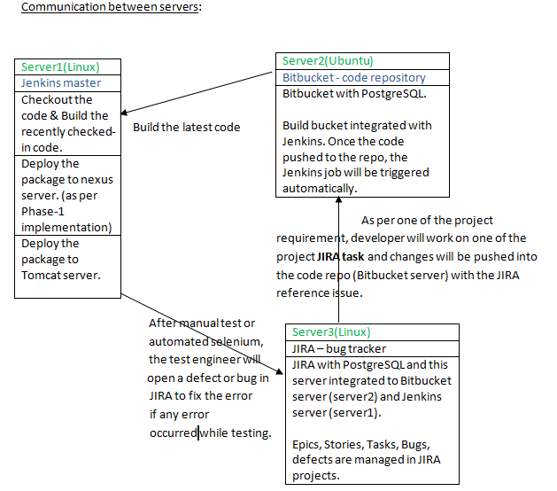

**Phase-5: Implementation**

|  |  |  |  |  |  |
| --- | --- | --- | --- | --- | --- |
| **Phases** | **Targeted Implementations** | **Tools Required** | **Number of instances** | **Status/duration** | **Supporting Documents** |
| **Phase-5.1** | Selenium Grid Installation | Java, Selenium JAR | Local Windows | Completed in one day | Jenkins+Maven+Selenium-OnLocalWindows.doc |
| **Phase-5.2** | Selenium + Maven + Jenkins with sample code web application automatic testing. | Java, Maven, Jenkins | Local Windows | Completed in one day | Refer the same above doc |
| **Phase-5.3** | AWS-Jenkins-Slaves-Linux-And-Windows-Configuration | Java | 2RHEL, 1 Windows - AWS | Completed in one day | AWS-Jenkins-Slaves-Linux-And-Windows-Configuration.doc |
| **Phase-5.4** | Selenium Grid Installation on AWS windows | Java, Selenium jar | 1 Windows | Completed in one day | Jenkins+Maven+Selenium-OnAWS.doc |
| **Phase-5.5** | Selenium + Maven + Jenkins on AWS Linux, Ubuntu, Windows instances | Java, Jenkins, Maven, Selenium Grid | 2RHEL,  1Windows | Completed in one day | Refer the same above doc |
| **Phase-5.6** | Documentation of Phase-5 tasks | Google Docs/sheets | - | Completed in one day | **DevOps-Setup-Phase5-Docs-v0.3.zip** |

Example work-flow:

Original Code check-in for web app 🡪 Prepare Selenium script to test the web pages in different browsers 🡪 Trigger a local maven build OR trigger a Jenkins job as to Build the original code 🡪 deploy the package to Tomcat server 🡪 build the Selenium job to run the automated test cases to check the web pages in different browsers.

Required Tools & servers:

|  |  |  |  |
| --- | --- | --- | --- |
| **Server/Type** | Server1(RHEL) | Server2 (RHEL) | Server3(Windows) |
| **Server Activity** | Jenkins master | Slave node to Jenkins master | Slave node to Jenkins master |
| **Tools** need to be installed | Java  Tomcat  Maven  Git  Jenkins | Java  Git  Maven  Tomcat | Java  Git  Maven  Selenium Grid  All required browsers |

Communication between servers:

|  |
| --- |
| Server2(Linux) |
| Slave node to Jenkins master |
| Always available |

|  |
| --- |
| Server1(Linux) |
| Jenkins master |
| Checkout the code & Build the original code. |
| Deploy the package to Tomcat server. |
| Run the Selenium job on Jenkins widows slave as to run the automated test cases to check the web pages in different browsers. |

Build the Original Code

|  |
| --- |
| Server3(Windows) |
| Slave node to Jenkins master |
| Only available to Selenium job. |

Run the Selenium script  
  
on windows